
Sec 5.3 –Trigonometry
Law of Cosines Name:
A
C
B
c
a
h
(b - x)
x
Law of Cosines: Start with cos (C) and the Pythagorean
theorem for both of the right triangles.

PROOF :

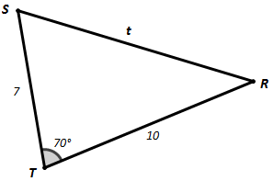
- Find the unknown sides and angles of each triangle using the Law of Cosines.

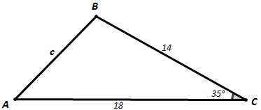

f
d
m∠D

t
m∠S
m∠R

AMDM Student Worksheets Created By Matthew M. Winking at Phoenix High School SECTION 5-3

p.57

- Find the unknown sides and angles of each triangle using the Law of Sines.

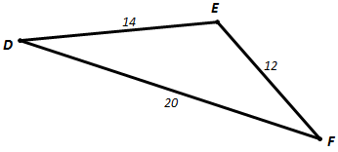
m∠D
m∠E
m∠F

- A centerfield baseball player caught a ball right at the deepest part of center field against the wall. From home plate to where the player caught the ball is 405 feet. The outfielder is trying to complete a double play by throwing the ball to first base. Using the diagram, how far did the outfielder need to throw the ball. (The bases are all laid out in a perfect square with each base 90 feet away from the next. Since it is a square you should be able to determine the angle created by 1st base – home plate – 2nd base)
?
405 ft
90 ft

AMDM Student Worksheets Created By Matthew M. Winking at Phoenix High School SECTION 5-3

p.58

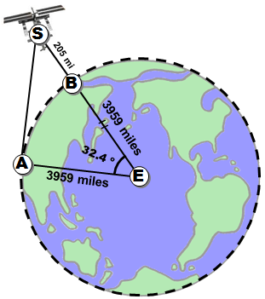
- On one night, a scientist needs to determine the distance she is away from the International Space Station. At the specific time she is determining this the space station distance they are both on the same line of longitude 77˚ E. Furthermore, she is on a latitude of 29˚ N and the space station is orbiting just above a latitude of 61.4˚ N. In short, the central angle between the two is 32.4˚. If the Earth’s radius is 3959 miles and the space station orbits 205 miles above the surface of the Earth, then how far is the scientist away from the space station?

AMDM Student Worksheets Created By Matthew M. Winking at Phoenix High School SECTION 5-3

p.59

